**LUPICAD MANAGEMENT SYSTEM**

**A PROJECT REPORT**

**Submitted in Partial Fulfillment of the requirements for the Award of the Degree of**

**Excven In**

**By**

Adil Husain

**DEPARTMENT OF WEBSITE DESIGNING**

**CERTIFICATE**

This is to certify that the dissertation entitled **“ Hospital Management System ”** is submitted by **ADIL HUSAIN** in their partial fulfillment of the requirement of the EXCEV IN PVT. LTD., Kakinada is a record of bonafide work carried out by them under my guidance and supervision.

**INTERNAL GUIDE: HEAD OF DEPARTMENT:**

**Google.com Mr. TEJPAL**

**ASSOCIATED MANAGER: Team Leader:**

**Mr. TEJPAL Mr. AHMED**

**Department of Web Development Department of Digital Marketing**

**ACKNOWLEDGEMENT**

It is indeed with a great pleasure and immense sense of gratitude that we acknowledge the help of these individuals. We are highly indebted to our Manager **Mr. Tejpal**, Excev In, for the facilities provided to accomplish this main project.

We would like to thank our **Mr. Tejpal**, Head of the Department of Excev In,for this constructive criticism throughout our project.

We feel elated in manifesting our sense of gratitude tour internal project guide **W3School, GeeksforGeeks, & Medicio-Free-Bootstrap-Theme**. He has been a constant source of inspiration for us and we are very deeply thankful to him for his support and valuable advice.

We extremely grateful to our Departmental staff members, Lab technicians and Non-teaching staff members for their extreme help throughout our project.

Finally we express our heartful thanks to all of our friends who helped us in successful completion of this project.

**Project Associates:**

**ADIL HUSAIN (Website Designer)**

**DECLARATION**

We hereby declare that project titled **“Hospital Management System ”** is a bonafide original record done by us at **EXCEV In,** during the period of 2022-2023 in **Excev In**, and also we state that this project has not been submitted anywhere in the partial fulfillment for any degree of this or any other Compnay.

**ABSTRACT**

The purpose of the project entitled as “HOSPITAL MANAGEMENT SYSTEM” is to computerize the Front Office Management of Hospital to develop software which is user friendly simple, fast, and cost – effective. It deals with the collection of patient’s information, diagnosis details, etc. Traditionally, it was done manually. The main function of the system is register and store patient details and doctor details and retrieve these details as and when required, and also to manipulate these details meaningfully System input contains patient details, diagnosis details, while system output is to get these details on to the screen. The Hospital Management System can be entered using a username and password. It is accessible either by an administrator or receptionist. Only they can add data into the database. The data can be retrieved easily. The data are well protected for personal use and makes the data processing very fast.

**INDEX**

1. INTRODUCTION

1.1 Introduction

1.2 Problem introduction

1.3 Modules in the project

2. REQUIREMENTS SPECIFICATION

2.1 Introduction

2.2 Hardware requirements

2.3 Software requirements

3. ANALYSIS

3.1 Existing System

3.2 Proposed System

3.3 Feasibility study

3.4 Software specification

4. UI DESIGN

4.1 Website Design

4.1.1 Introduction to UI

5. SYSTEM IMPLEMENTATION

5.1 Sample code

6. TESTING

6.1 Introduction

6.2 testing methods

7. SAMPLE SCREENSHOTS

8. CONCLUSION

CHAPTER 1

**INTRODUCTION**

**1.1 Introduction:**

The project Hospital Management system includes registration of patients, storing their details into the system, and also computerized billing in the pharmacy, and labs. The software has the facility to give a unique id for every patient and stores the details of every patient and the staff automatically. It includes a search facility to know the current status of each room. User can search availability of a doctor and the details of a patient using the id.

The Hospital Management System can be entered using a username and password. It is accessible either by an administrator or receptionist. Only they can add data into the database. The data can be retrieved easily. The interface is very user-friendly. The data are well protected for personal use and makes the data processing very fast.

Hospital Management System is powerful, flexible, and easy to use and is designed and developed to deliver real conceivable benefits to hospitals.

Hospital Management System is designed for multispeciality hospitals, to cover a wide range of hospital administration and management processes. It is an integrated end-to-end Hospital Management System that provides relevant information across the hospital to support effective decision making for patient care, hospital administration and critical financial accounting, in a seamless flow.

Hospital Management System is a software product suite designed to improve the quality and management of hospital management in the areas of clinical process analysis and activity-based costing. Hospital Management System enables you to develop your organization and improve its effectiveness and quality of work. Managing the key processes efficiently is critical to the success of the hospital helps you manage your processes

**1.2 Problem Introduction:**

**Lack of immediate retrievals: -**

The information is very difficult to retrieve and to find particular information like- E.g. - To find out about the patient’s history, the user has to go through various registers. This results in in convenienceand wastage of time.

**Lack of immediate information storage: -**

The information generated by various transactions takes time and efforts to be stored at right place.

**Lack of prompt updating: -**

Various changes to information like patient details or immunization details of child are difficult to make as paper work is involved.

**Error prone manual calculation: -**

Manual calculations are error prone and take a lot of time this may result in incorrect information. For example calculation of patient’s bill based on various treatments.

**Preparation of accurate and prompt reports: -**

This becomes a difficult task as information is difficult to collect from various register.

**Objective:-**

1. Define hospital
2. Recording information about the Patients that come.
3. Generating bills.
4. Recording information related to diagnosis given to Patients.
5. Keeping record of the Immunization provided to children/patients.
6. Keeping information about various diseases and medicines available to cure them.

These are the various jobs that need to be done in a Hospital by the operational staff andDoctors. All these works are done on papers.

**Scope of the Project:-**

1. Information about Patients is done by just writing the Patients name, age and gender. Whenever the Patient comes up his information is stored freshly.
2. Bills are generated by recording price for each facility provided to Patient on a separate sheet and at last they all are summed up.
3. Diagnosis information to patients is generally recorded on the document, which contains Patient information. It is destroyed after some time period to decrease the paper load in the office.
4. Immunization records of children are maintained in pre-formatted sheets, which are kept in a file.
5. Information about various diseases is not kept as any document. Doctors themselves do this job by remembering various medicines.

All this work is done manually by the receptionist and other operational staff and lot of papers are needed to be handled and taken care of. Doctors have to remember various medicines available for diagnosis and sometimes miss better alternatives as they can’t remember them at that time.

**1.3 MODULES:**

The entire project mainly consists of 7 modules, which are

* Admin module
* User module (patient)
* Doctor module
* Nurse module
* Pharmacist module
* Laboratorist module
* Accountant module

**1.3.1 Admin module:**

* manage department of hospitals, user, doctor, nurse, pharmacist, laboratorist accounts.
* watch appointment of doctors
* watch transaction reports of patient payment
* Bed ,ward, cabin status
* watch blood bank report
* watch medicine status of hospital stock
* watch operation report
* watch birth report
* watch diagnosis report
* watch death report

**1.3.2 user module(patient):**

* View appointment list and status with doctors
* View prescription details
* View medication from doctor
* View doctor list
* View blood bank status
* View operation history
* View admit history. like bed, ward icu etc
* Manage own profile

**1.3.3 Doctor module:**

* Manage patient. account opening and updating
* Create, manage appointment with patient
* Create prescription for patient
* Provide medication for patients
* Issue for operation of patients and creates operation report
* Manage own profile

**1.3.4 Nurse module:**

* Manage patient. account opening and updating
* Allot bed, ward, cabin for patients
* Provide medication according to patient prescription
* Manage blood bank and update status
* Keep record of patient operation, baby born and death of patient
* Manage own profile

**1.3.5 Pharmacist module:**

* Maintain medicine
* Keep records of hospitals stock medicines and status
* Manage medicine categories
* Watch prescription of patient
* Provide medication to prescriptions

**1.3.6 Laboratorist module:**

* Watch prescription list
* Upload diagnostic report
* Preview of report files. like xray images, ct scan, mri reports
* Manage own profile

**1.3.7 Accountant module:**

* Create invoice for payment
* Order invoice to patient
* Take cash payment
* Watch payment history of patients
* Manage own profile

CHAPTER 2

**REQUIREMENT SPECIFICATION**

**2.1 INTRODUCTION:**

To be used efficiently, all computer software needs certain hardware components or the other software resources to be present on a computer. These pre-requisites are known as(computer) system requirements and are often used as a guideline as opposed to an absolute rule. Most software defines two sets of system requirements: minimum and recommended. With increasing demand for higher processing power and resources in newer versions of software, system requirements tend to increase over time. Industry analysts suggest that this trend plays a biggerpart in driving upgrades to existing computer systems than technological advancements.

**2.2 HARDWARE REQUIREMENTS:**

The most common set of requirements defined by any operating system or software application is the physical computer resources, also known as hardware. A hardware requirements list is often accompanied by a hardware compatibility list (DELL), especially in case of operating systems. An DELL lists tested, compatibility and sometimes incompatible hardware devices for a particular operating system or application. The following sub-sections discuss the various aspects of hardware requirements.

**HARDWARE REQUIREMENTS FOR PRESENT PROJECT**:

PROCESSOR : Intel dual Core ,i3

RAM : 1 GB

HARD DISK : 80 GB

**2.3 SOFTWARE REQUIREMENTS:**

Software Requirements deal with defining software resource requirements and pre-requisites that need to be installed on a computer to provide optimal functioning of an application. These requirements or pre-requisites are generally not included in the software installation package and need to be installed separately before the software is installed.

**SOFTWARE REQUIREMENTS FOR PRESENT PROJECT:**

OPERATING SYSTEM : Windows 7/ XP/8/10/11

FRONT END : Html,css,java script & Bootstrap

SERVER SIDE SCRIPT : Python

DATABASE : Mysql

**CHAPTER 3**

**ANALYSIS**

**3.1EXISTING SYSTEM:**

Hospitals currently use a manual system for the management and maintainance of critical information. The current system requires numerous paper forms, with data stores spread through out the hospital management infrastructure. Often information is incomplete or does not follow management standards. Forms are often lost in transit between departments requiring a comprehensive auditing process to ensure that no vital information is lost. Multiple copies of the same information exist in the hospital and may lead to inconsistencies in data in various data stores.

**3.2 PROPOSED SYSTEM:**

The Hospital Management System is designed for any hospital to replace their existing manual paper based system. The new system is to control the information of patients. Room availability, staff and operating room schedules and patient invoices. These services are to be provided in an efficient, cost effective manner, with the goal of reducing the time and resources currently required for such tasks .

**3.3 FEASIBILITY STUDY**

The feasibility of the project is analysed in this phase and business proposal is put forth with a very general plan for the project and some cost estimates. During system analysis the feasibility study of the proposed system is to be carried out. This is to ensure that the proposed system is not a burden to the company. For feasibility analysis, some understanding of the major requirements for the system is essential.

Three key considerations involved in the feasibility analysis are:

**3.3.1 Economic Feasibility**

This study is carried out to check the economic impact will have on the system will have on the organization. The amount of fund that the company can pour into the research and development of the system is limited. The expenditures must be justified. Thus the developed system as well within the budget and this was achieved because most of the technologies used are freely available. Only the customised products have to be purchased.

**3.3.2 Technical Feasibility**

This study is carried out to check the technical feasibility, that is,the technical requirements of the system. Any system developed must not have a high demand on the available available technical resources. This will lead to high demands being placed on the client. The developed system must have a modest requirement, as only minimal or null changes for the implementing this system.

**3.3.3 Operational Feasibility**

The aspect of study is to check the level of acceptance of the system by the user. This includes the process of training the user to use the system efficiently. The user must not feel threatened by the system, instead must accept it as a necessity. The level of acceptance by the users solely depends on the methods that are employed to educate the user about the system and to make him familiar with it. His level of confidence must be raised so that he is also able to make some constructive criticism, which is welcomed, as he is the final user of the system.

**3.4 SOFTWARE SPECIFICATION**

**HTML:**

**HTML** or **Hypertext Markup Language** is the standard [markup language](http://en.wikipedia.org/wiki/Markup_language) used to create [web pages](http://en.wikipedia.org/wiki/Web_page).

HTML is written in the form of [HTML elements](http://en.wikipedia.org/wiki/HTML_element) consisting of *tags* enclosed in [angle brackets](http://en.wikipedia.org/wiki/Angle_brackets) (like <html>). HTML tags most commonly come in pairs like <h1> and </h1>, although some tags represent *empty elements* and so are unpaired, for example <img>. The first tag in a pair is the *start tag*, and the second tag is the *end tag* (they are also called *opening tags* and *closing tags*). Though not always necessary, it is best practice to append a slash to tags which are not paired with a closing tag.

The purpose of a [web browser](http://en.wikipedia.org/wiki/Web_browser) is to read HTML documents and compose them into visible or audible web pages. The browser does not display the HTML tags, but uses the tags to interpret the content of the page. HTML describes the structure of a website [semantically](http://en.wikipedia.org/wiki/Semantic) along with cues for presentation, making it a [markup language](http://en.wikipedia.org/wiki/Markup_language) rather than a [programming language](http://en.wikipedia.org/wiki/Programming_language).

HTML elements form the building blocks of all [websites](http://en.wikipedia.org/wiki/Website). HTML allows [images and objects](http://en.wikipedia.org/wiki/Img_(HTML_element)) to be embedded and can be used to create [interactive forms](http://en.wikipedia.org/wiki/Fieldset). It provides a means to create [structured documents](http://en.wikipedia.org/wiki/Structured_document) by denoting structural [semantics](http://en.wikipedia.org/wiki/Semantic) for text such as headings, paragraphs, lists, [links](http://en.wikipedia.org/wiki/Hyperlink), quotes and other items. It can embed [scripts](http://en.wikipedia.org/wiki/Scripting_language) written in languages such as [JavaScript](http://en.wikipedia.org/wiki/JavaScript) which affect the behavior of HTML web pages.

**CASCADING STYLE SHEETS** (**CSS**):

It is a [style sheet language](http://en.wikipedia.org/wiki/Style_sheet_language) used for describing the [look and formatting](http://en.wikipedia.org/wiki/Presentation_semantics) of a document written in a [markup language](http://en.wikipedia.org/wiki/Markup_language). While most often used to style [web pages](http://en.wikipedia.org/wiki/Web_page) and [interfaces](http://en.wikipedia.org/wiki/Interface_(computing)) written in [HTML](http://en.wikipedia.org/wiki/HTML) and [XHTML](http://en.wikipedia.org/wiki/XHTML), the language can be applied to any kind of [XML](http://en.wikipedia.org/wiki/XML) document, including [plain XML](http://en.wikipedia.org/wiki/Plain_Old_XML), [SVG](http://en.wikipedia.org/wiki/Scalable_Vector_Graphics) and [XUL](http://en.wikipedia.org/wiki/XUL). CSS is a cornerstone specification of [the web](http://en.wikipedia.org/wiki/The_web) and almost all web pages use CSS style sheets to describe their presentation.

CSS is designed primarily to enable the separation of document content from document presentation, including elements such as the [layout](http://en.wikipedia.org/wiki/Page_layout), [colors](http://en.wikipedia.org/wiki/Color), and [fonts](http://en.wikipedia.org/wiki/Typeface).[[1]](http://en.wikipedia.org/wiki/Cascading_Style_Sheets#cite_note-1) This separation can improve content [accessibility](http://en.wikipedia.org/wiki/Accessibility), provide more flexibility and control in the specification of presentation characteristics, enable multiple pages to share formatting, and reduce complexity and repetition in the structural content .

CSS can also allow the same markup page to be presented in different styles for different rendering methods, such as on-screen, in print, by voice (when read out by a speech-based browser or [screen reader](http://en.wikipedia.org/wiki/Screen_reader)) and on [Braille-based](http://en.wikipedia.org/wiki/Braille_display), tactile devices. It can also be used to allow the web page to display differently depending on the screen size or device on which it is being viewed. While the author of a document typically links that document to a CSS file, readers can use a different style sheet, perhaps one on their own computer, to override the one the author has specified. However if the author or the reader did not link the document to a specific style sheet the default style of the browser will be applied.

**MySQL:**

MySQL is developed, distributed, and supported by Oracle Corporation. MySQL is a database system used on the web it runs on a server. MySQL is ideal for both small and large applications. It is very fast, reliable, and easy to use. It supports standard SQL. MySQL can be compiled on a number of platforms.

The data in MySQL is stored in tables. A table is a collection of related data, and it consists of columns and rows. Databases are useful when storing information categorically.

**FEATURES OF MySQL:**

Internals and portability:

* Written in C and C++.
* Tested with a broad range of different compilers.
* Works on many different platforms.
* Tested with Purify (a commercial memory leakage detector) as well as with Val grind, a GPL tool.
* Uses multi-layered server design with independent modules.

#### Security:

* A privilege and password system that is very flexible and secure, and that enables host-based verification.
* Password security by encryption of all password traffic when you connect to a server.

#### Scalability and Limits:

* Support for large databases. We use MySQL Server with databases that contain 50 million records. We also know of users who use MySQL Server with 200,000 tables and about 5,000,000,000 rows.
* Support for up to 64 indexes per table (32 before MySQL 4.1.2). Each index may consist of 1 to 16 columns or parts of columns. The maximum index width is 767 bytes for **InnoDB** tables, or 1000 for **MyISAM**; before MySQL 4.1.2, the limit is 500 bytes. An index may use a prefix of a column for [**CHAR**](https://dev.mysql.com/doc/refman/5.0/en/char.html), [**VARCHAR**](https://dev.mysql.com/doc/refman/5.0/en/char.html), [**BLOB**](https://dev.mysql.com/doc/refman/5.0/en/blob.html), or [**TEXT**](https://dev.mysql.com/doc/refman/5.0/en/blob.html) column types.

#### CONNECTIVITY:

Clients can connect to MySQL Server using several protocols:

* Clients can connect using TCP/IP sockets on any platform.
* On Windows systems in the NT family (NT, 2000, XP, 2003, or Vista), clients can connect using named pipes if the server is started with the [--enable-named-pipe](https://dev.mysql.com/doc/refman/5.0/en/server-options.html#option_mysqld_enable-named-pipe) option. In MySQL 4.1 and higher, Windows servers also support shared-memory connections if started with the [--shared-memory](https://dev.mysql.com/doc/refman/5.0/en/server-options.html#option_mysqld_shared-memory) option. Clients can connect through shared memory by using the --protocol=memory option.
* On UNIX systems, clients can connect using Unix domain socket files.

#### LOCALIZATION:

* The server can provide error messages to clients in many languages.
* All data is saved in the chosen character set.

**CLIENTS AND TOOLS**:

* MySQL includes several client and utility programs. These include both command-line programs such as [**mysqldump**](https://dev.mysql.com/doc/refman/5.0/en/mysqldump.html) and [**mysqladmin**](https://dev.mysql.com/doc/refman/5.0/en/mysqladmin.html), and graphical programs such as [MySQL Workbench](http://dev.mysql.com/doc/refman/5.1/en/workbench.html).
* MySQL Server has built-in support for SQL statements to check, optimize, and repair tables. These statements are available from the command line through the [**mysqlcheck**](https://dev.mysql.com/doc/refman/5.0/en/mysqlcheck.html) client. MySQL also includes [**myisamchk**](https://dev.mysql.com/doc/refman/5.0/en/myisamchk.html), a very fast command-line utility for performing these operations on **MyISAM** tables.
* MySQL programs can be invoked with the --help or -? option to obtain online assistance.

**WHY TO USE MySQL:**

* Leading open source RDBMS
* Ease of use – No frills
* Fast
* Robust
* Security
* Multiple OS support
* Free
* Technical support
* Support large database– up to 50 million rows, file size limit up to 8 Million TB

**JAVASCRIPT:**

JavaScript is the scripting language of the Web. All modern HTML pages are using JavaScript. A scripting language is a lightweight programming language.JavaScript code can be inserted into any HTML page, and it can be executed by all types of web browsers. JavaScript is easy to learn.

**WHY TO USE JAVASCRIPT**:

JavaScript is one of the 3 languages all web developers  must learn:

1. HTML to define the content of web pages
2. CSS to specify the layout of web pages
3. JavaScript to specify the behavior of web pages

Example

x = document.getElementById("demo");  //Find the HTML element with id="demo"  
x.innerHTML = "Hello JavaScript";     //Change the content of the HTML element

**document.getElementById()** is one of the most commonly used HTML DOM methods.

**OTHER USES OF JAVASCRIPT**:

* Delete HTML elements
* Create new HTML elements
* Copy HTML elements
* In HTML, JavaScript is a sequence of statements that can be executed by the web browser.

**JAVASCRIPT STATEMENTS**:

* JavaScript statements are "commands" to the browser.
* The purpose of the statements is to tell the browser what to do.
* This JavaScript statement tells the browser to write "Hello Dolly" inside an HTML element with id="demo":

Semicolon;

* Semicolon separates JavaScript statements.
* Normally you add a semicolon at the end of each executable statement.
* Using semicolons also makes it possible to write many statements on one line.

**JAVASCRIPT CODE:**

* JavaScript code (or just JavaScript) is a sequence of JavaScript statements.
* Each statement is executed by the browser in the sequence they are written.
* This example will manipulate two HTML elements:
* Example
* document.getElementById("demo").innerHTML="Hello Dolly";  
  document.getElementById("myDIV").innerHTML="How are you?";

## JAVASCRIPT PROPERTIES:

* Properties are the values associated with a JavaScript object.
* A JavaScript object is a collection of unordered properties.
* Properties can usually be changed, added, and deleted, but some are read only.

**PYTHON:**

**WHAT IS PYTHON?**

* PYTHON is Object Oriented Programing Language".
* PYTHON is a widely-used, open source scripting language
* PYTHON scripts are executed on the server
* PYTHON costs nothing, it is free to download and use

**WHAT IS PYTHON FILE?**

* PYTHON files can contain text, HTML, CSS, JavaScript, and PYTHON code
* PYTHON code are executed on the server, and the result is returned to the browser as plain HTML
* PYTHON files have extension ".Py"

**WHAT CAN PYTHON DO?**

* PYTHON can generate dynamic page content
* PYTHON can create, open, read, write, delete, and close files on the server
* PYTHON can collect form data
* PYTHON can send and receive cookies
* PYTHON can add, delete, modify data in your database
* PYHON can restrict users to access some pages on your website
* PYHTON can encrypt data

With PYTHON you are not limited to output HTML. You can output images, PDF files, and even Flash movies. You can also output any text, such as XHTML and XML.

**WHY PYTHON?**

* PYTHON runs on various platforms (Windows, Linux, Unix, Mac OS X, etc.)
* PYTHON is compatible with almost all servers used today (Apache, IIS, etc.)
* PYTHON supports a wide range of databases
* PYTHON is free. Download it from the official PYTHON resource: https://www.python.org/

**CHAPTER 4**

**DESIGN**

4.1 SYSTEM DESIGN:

4.1.1INTRODUCTION TO UI:

**UI Design**

User Interface (UI) Design focuses on anticipating what users might need to do and ensuring that the interface has elements that are easy to access, understand, and use to facilitate those actions. UI brings together concepts from [interaction design](https://www.usability.gov/what-and-why/interaction-design.html), [visual design](https://www.usability.gov/what-and-why/visual-design.html), and [information architecture](https://www.usability.gov/what-and-why/information-architecture.html).

**Use case diagram of our project:**



**Class Diagram**:

A Class is a category or group of things that has similar attributes and common behavior. A Rectangle is the icon that represents the class it is divided into three areas. The upper most area contains the name, the middle; area contains the attributes and the lowest areas show the operations. Class diagrams provides the representation that developers work from. Class diagrams help on the analysis side, too.



**Sequence diagram:**

A **Sequence Diagram** is an interaction diagram that emphasis the time ordering of messages; a collaboration diagram is an interaction diagram that emphasizes the structural organization of the objects that send and receive messages. Sequence diagrams and collaboration diagrams are isomorphic, meaning that you can take one and transform it into the other.



**Collaboration diagram:**

A **Collaboration Diagram** also called a communication diagram or interaction diagram, is an illustration of the relationships and interactions among software objects. The concept is more than a decade old although it has been refined as modeling paradigms have evolved.



**Deployement diagram:**

A **Deployment Diagram** shows the configuration of run-time processing nodes and the components that live on them. Deployment diagrams address the static deployment view of architecture. They are related to component diagrams in that a node typically encloses one or more components.



**Statechart Diagrams:**

The state diagram shows the states of an object and represents activities as arrows connecting the states. The Activity Diagram highlights the activities. Each activity is represented by a rounded rectangle-narrower and more oval-shaped than the state icon. An arrow represents the transition from the one activity to the next. The activity diagram has a starting point represented by filled-in circle, and an end point represented by bulls eye.



**CHAPTER 5**

**SYSTEM IMPLEMENTATION**

**5. IMPLEMENTATION:**

**5.1 Inroduction:**

Implementation is the stage of the project when the theoretical design is turned out into a working system. Thus it can be considered to be the most critical stage in achieving a successful new system and in giving the user, confidence that the new system will work and be effective.

The implementation stage involves careful planning, investigation of the existing system and it’s constraints on implementation, designing of methods to achieve changeover and evaluation of changeover methods.

**5.2 Sample code:**

**Home.html:**

<!DOCTYPE html>

<html lang="en">

<head>

<meta charset="utf-8">

<meta content="width=device-width, initial-scale=1.0" name="viewport">

<title>Lupicad</title>

<meta content="" name="description">

<meta content="" name="keywords">

<!-- Favicons -->

<link href="assets/img/l.png" rel="icon">

<link href="assets/img/apple-touch-icon.png" rel="apple-touch-icon">

<!-- Google Fonts -->

<link href="https://fonts.googleapis.com/css?family=Open+Sans:300,300i,400,400i,600,600i,700,700i|Roboto:300,300i,400,400i,500,500i,600,600i,700,700i|Poppins:300,300i,400,400i,500,500i,600,600i,700,700i" rel="stylesheet">

<!-- Vendor CSS Files -->

<link href="assets/vendor/fontawesome-free/css/all.min.css" rel="stylesheet">

<link href="assets/vendor/animate.css/animate.min.css" rel="stylesheet">

<link href="assets/vendor/aos/aos.css" rel="stylesheet">

<link href="assets/vendor/bootstrap/css/bootstrap.min.css" rel="stylesheet">

<link href="assets/vendor/bootstrap-icons/bootstrap-icons.css" rel="stylesheet">

<link href="assets/vendor/boxicons/css/boxicons.min.css" rel="stylesheet">

<link href="assets/vendor/glightbox/css/glightbox.min.css" rel="stylesheet">

<link href="assets/vendor/swiper/swiper-bundle.min.css" rel="stylesheet">

<!-- Template Main CSS File -->

<link href="assets/css/style.css" rel="stylesheet">

</head>

<body>

<!-- ======= Top Bar ======= -->

<div id="topbar" class="d-flex align-items-center fixed-top">

<div class="container d-flex align-items-center justify-content-center justify-content-md-between">

<div class="align-items-center d-none d-md-flex">

<i class="bi bi-clock"></i> Service || 24*7 Available

</div>

<div class="d-flex align-items-center">

<i class="bi bi-phone"></i> Call us now +91 70650 65118

</div>

</div>

</div>

<!-- ======= Header ======= -->

<header id="header" class="fixed-top">

<div class="container d-flex align-items-center">

<!--

<a href="index.html" class="logo me-auto"><img src="assets/img/logo.png" alt=""></a> -->

<!--Uncomment below if you prefer to use an image logo -->

<h1 class="logo me-auto"><a href="index.html">Lupicad</a></h1>

<nav id="navbar" class="navbar order-last order-lg-0">

<ul>

<li><a class="nav-link scrollto " href="#hero">Home</a></li>

<li><a class="nav-link scrollto" href="#about">About</a></li>

<li><a class="nav-link scrollto" href="#services">Services</a></li>

<li><a class="nav-link scrollto" href="#departments">Departments</a></li>

<li><a class="nav-link scrollto" href="#doctors">Doctors</a></li>

<li class="dropdown"><a href="#"><span>Products</span> <i class="bi bi-chevron-down"></i></a>

<ul>

<li><a href="#">Hulk Power</a></li>

<li class="dropdown"><a href="#"><span>Add Products</span> <i class="bi bi-chevron-right"></i></a>

<ul>

<li><a href="#">Deep Drop Down 1</a></li>

<li><a href="#">Deep Drop Down 2</a></li>

<li><a href="#">Deep Drop Down 3</a></li>

<li><a href="#">Deep Drop Down 4</a></li>

<li><a href="#">Deep Drop Down 5</a></li>

</ul>

</li>

<li><a href="#">Iron Man</a></li>

<li><a href="#">Man Fuel</a></li>

<li><a href="#">Target Power</a></li>

</ul>

</li>

<li><a class="nav-link scrollto" href="#contact">Contact</a></li>

</ul>

<i class="bi bi-list mobile-nav-toggle"></i>

</nav><!-- .navbar -->

<a href="#appointment" class="appointment-btn scrollto"><span class="d-none d-md-inline">Make an</span> Appointment</a>

</div>

</header><!-- End Header -->

<!-- ======= Hero Section ======= -->

<section id="hero">

<div id="heroCarousel" data-bs-interval="5000" class="carousel slide carousel-fade" data-bs-ride="carousel">

<ol class="carousel-indicators" id="hero-carousel-indicators"></ol>

<div class="carousel-inner" role="listbox">

<!-- Slide 1 -->

<div class="carousel-item active" style="background-image: url(assets/img/slide/slide-0.jpg)">

<div class="container">

<h2>Welcome to <span>Lupicad</span></h2>

<!-- <p>Ut velit est quam dolor ad a aliquid qui aliquid. Sequi ea ut et est quaerat sequi nihil ut aliquam. Occaecati alias dolorem mollitia ut. Similique ea voluptatem. Esse doloremque accusamus repellendus deleniti vel.</p> -->

<a href="#about" class="btn-get-started scrollto">Read More</a>

</div>

</div>

<!-- Slide 2 -->

<div class="carousel-item" style="background-image: url(assets/img/slide/slide--1.jpg)">

<div class="container">

<h2>Lorem Ipsum Dolor</h2>

<!-- <p>Ut velit est quam dolor ad a aliquid qui aliquid. Sequi ea ut et est quaerat sequi nihil ut aliquam. Occaecati alias dolorem mollitia ut. Similique ea voluptatem. Esse doloremque accusamus repellendus deleniti vel.</p> -->

<a href="#about" class="btn-get-started scrollto">Read More</a>

</div>

</div>

<!-- Slide 3 -->

<div class="carousel-item" style="background-image: url(assets/img/slide/slide.jpg)">

<div class="container">

<h2>Sequi ea ut et est quaerat</h2>

<!-- <p>Ut velit est quam dolor ad a aliquid qui aliquid. Sequi ea ut et est quaerat sequi nihil ut aliquam. Occaecati alias dolorem mollitia ut. Similique ea voluptatem. Esse doloremque accusamus repellendus deleniti vel.</p> -->

<a href="#about" class="btn-get-started scrollto">Read More</a>

</div>

</div>

</div>

<a class="carousel-control-prev" href="#heroCarousel" role="button" data-bs-slide="prev">

<span class="carousel-control-prev-icon bi bi-chevron-left" aria-hidden="true"></span>

</a>

<a class="carousel-control-next" href="#heroCarousel" role="button" data-bs-slide="next">

<span class="carousel-control-next-icon bi bi-chevron-right" aria-hidden="true"></span>

</a>

</div>

</section><!-- End Hero -->

<main id="main">

<!-- ======= Featured Services Section ======= -->

<section id="featured-services" class="featured-services">

<div class="container" data-aos="fade-up">

<div class="row">

<div class="col-md-6 col-lg-3 d-flex align-items-stretch mb-5 mb-lg-0">

<div class="icon-box" data-aos="fade-up" data-aos-delay="100">

<div class="icon"><i class="fas fa-heartbeat"></i></div>

<h4 class="title"><a href="">Lorem Ipsum</a></h4>

<p class="description">Voluptatum deleniti atque corrupti quos dolores et quas molestias excepturi</p>

</div>

</div>

<div class="col-md-6 col-lg-3 d-flex align-items-stretch mb-5 mb-lg-0">

<div class="icon-box" data-aos="fade-up" data-aos-delay="200">

<div class="icon"><i class="fas fa-pills"></i></div>

<h4 class="title"><a href="">Sed ut perspiciatis</a></h4>

<p class="description">Duis aute irure dolor in reprehenderit in voluptate velit esse cillum dolore</p>

</div>

</div>

<div class="col-md-6 col-lg-3 d-flex align-items-stretch mb-5 mb-lg-0">

<div class="icon-box" data-aos="fade-up" data-aos-delay="300">

<div class="icon"><i class="fas fa-thermometer"></i></div>

<h4 class="title"><a href="">Magni Dolores</a></h4>

<p class="description">Excepteur sint occaecat cupidatat non proident, sunt in culpa qui officia</p>

</div>

</div>

<div class="col-md-6 col-lg-3 d-flex align-items-stretch mb-5 mb-lg-0">

<div class="icon-box" data-aos="fade-up" data-aos-delay="400">

<div class="icon"><i class="fas fa-dna"></i></div>

<h4 class="title"><a href="">Nemo Enim</a></h4>

<p class="description">At vero eos et accusamus et iusto odio dignissimos ducimus qui blanditiis</p>

</div>

</div>

</div>

</div>

</section><!-- End Featured Services Section -->

<!-- ======= Cta Section ======= -->

<section id="cta" class="cta">

<div class="container" data-aos="zoom-in">

<div class="text-center">

<h3>In an emergency? Need help now?</h3>

<p> Duis aute irure dolor in reprehenderit in voluptate velit esse cillum dolore eu fugiat nulla pariatur. Excepteur sint occaecat cupidatat non proident, sunt in culpa qui officia deserunt mollit anim id est laborum.</p>

<a class="cta-btn scrollto" href="#appointment">Make an Make an Appointment</a>

</div>

</div>

</section><!-- End Cta Section -->

**ABOUT.html:**

<section id="about" class="about">

<div class="container" data-aos="fade-up">

<div class="section-title">

<h2>About Us</h2>

</div>

<p>Magnam dolores commodi suscipit. Necessitatibus eius consequatur ex aliquid fuga eum quidem. Sit sint consectetur velit. Quisquam quos quisquam cupiditate. Et nemo qui impedit suscipit alias ea. Quia fugiat sit in iste officiis commodi quidem hic quas.</p>

<div class="row">

<div class="col-lg-6" data-aos="fade-right">

<img src="assets/img/slide.jpg" class="img-fluid" alt="">

<img src="assets/img/about1.jpg" class="img-fluid" alt="">

</div>

<div class="col-lg-6 pt-4 pt-lg-0 content" data-aos="fade-left">

<h3>Voluptatem dignissimos provident quasi corporis voluptates sit assumenda.</h3>

<p class="fst-italic">

Lorem ipsum dolor sit amet, consectetur adipiscing elit, sed do eiusmod tempor incididunt ut labore et dolore

magna aliqua.

</p>

<ul>

<li><i class="bi bi-check-circle"></i> Ullamco laboris nisi ut aliquip ex ea commodo consequat.</li>

<li><i class="bi bi-check-circle"></i> Duis aute irure dolor in reprehenderit in voluptate velit.</li>

<li><i class="bi bi-check-circle"></i> Ullamco laboris nisi ut aliquip ex ea commodo consequat. Duis aute irure dolor in reprehenderit in voluptate trideta storacalaperda mastiro dolore eu fugiat nulla pariatur.</li>

</ul>

<p>

Ullamco laboris nisi ut aliquip ex ea commodo consequat. Duis aute irure dolor in reprehenderit in voluptate

velit esse cillum dolore eu fugiat nulla pariatur. Excepteur sint occaecat cupidatat non proident, sunt in

culpa qui officia deserunt mollit anim id est laborum

</p>

</div>

</div>

</div>

</section><!-- End About Us Section -->

<!-- ======= Counts Section ======= -->

<section id="counts" class="counts">

<div class="container" data-aos="fade-up">

<div class="row no-gutters">

<div class="col-lg-3 col-md-6 d-md-flex align-items-md-stretch">

<div class="count-box">

<i class="fas fa-user-md"></i>

<span data-purecounter-start="0" data-purecounter-end="85" data-purecounter-duration="1" class="purecounter"></span>

<p><strong>Doctors</strong><br> consequuntur quae qui deca rode</p>

<a href="#">Find out more &raquo;</a>

</div>

</div>

<div class="col-lg-3 col-md-6 d-md-flex align-items-md-stretch">

<div class="count-box">

<i class="far fa-hospital"></i>

<span data-purecounter-start="0" data-purecounter-end="26" data-purecounter-duration="1" class="purecounter"></span>

<p><strong>Departments</strong><br> adipisci atque cum quia aut numquam delectus</p>

<a href="#">Find out more &raquo;</a>

</div>

</div>

<div class="col-lg-3 col-md-6 d-md-flex align-items-md-stretch">

<div class="count-box">

<i class="fas fa-flask"></i>

<span data-purecounter-start="0" data-purecounter-end="14" data-purecounter-duration="1" class="purecounter"></span>

<p><strong>Research Lab</strong><br> aut commodi quaerat. Aliquam ratione</p>

<a href="#">Find out more &raquo;</a>

</div>

</div>

<div class="col-lg-3 col-md-6 d-md-flex align-items-md-stretch">

<div class="count-box">

<i class="fas fa-award"></i>

<span data-purecounter-start="0" data-purecounter-end="150" data-purecounter-duration="1" class="purecounter"></span>

<p><strong>Awards</strong><br> rerum asperiores dolor molestiae doloribu</p>

<a href="#">Find out more &raquo;</a>

</div>

</div>

</div>

</div>

</section><!-- End Counts Section -->

<!-- ======= Features Section ======= -->

<section id="features" class="features">

<div class="container" data-aos="fade-up">

<div class="row">

<div class="col-lg-6 order-2 order-lg-1" data-aos="fade-right">

<div class="icon-box mt-5 mt-lg-0">

<i class="bx bx-receipt"></i>

<h4>Est labore ad</h4>

<p>Consequuntur sunt aut quasi enim aliquam quae harum pariatur laboris nisi ut aliquip</p>

</div>

<div class="icon-box mt-5">

<i class="bx bx-cube-alt"></i>

<h4>Harum esse qui</h4>

<p>Excepteur sint occaecat cupidatat non proident, sunt in culpa qui officia deserunt</p>

</div>

<div class="icon-box mt-5">

<i class="bx bx-images"></i>

<h4>Aut occaecati</h4>

<p>Aut suscipit aut cum nemo deleniti aut omnis. Doloribus ut maiores omnis facere</p>

</div>

<div class="icon-box mt-5">

<i class="bx bx-shield"></i>

<h4>Beatae veritatis</h4>

<p>Expedita veritatis consequuntur nihil tempore laudantium vitae denat pacta</p>

</div>

</div>

<div class="image col-lg-6 order-1 order-lg-2" style='background-image: url("assets/img/features1.jpg");' data-aos="zoom-in"></div>

</div>

</div>

</section>

**SERVICE.html**

<section id="services" class="services services">

<div class="container" data-aos="fade-up">

<div class="section-title">

<h2>Services</h2>

<p>Magnam dolores commodi suscipit. Necessitatibus eius consequatur ex aliquid fuga eum quidem. Sit sint consectetur velit. Quisquam quos quisquam cupiditate. Et nemo qui impedit suscipit alias ea. Quia fugiat sit in iste officiis commodi quidem hic quas.</p>

</div>

<div class="row">

<div class="col-lg-4 col-md-6 icon-box" data-aos="zoom-in" data-aos-delay="100">

<div class="icon"><i class="fas fa-heartbeat"></i></div>

<h4 class="title"><a href="">Lorem Ipsum</a></h4>

<!-- <p class="description">Voluptatum deleniti atque corrupti quos<br>dolores et quas molestias excepturi sint<br>occaecati cupiditate non provident</p> -->

</div>

<div class="col-lg-4 col-md-6 icon-box" data-aos="zoom-in" data-aos-delay="200">

<div class="icon"><i class="fas fa-pills"></i></div>

<h4 class="title"><a href="">Dolor Sitema</a></h4>

<!-- <p class="description">Minim veniam, quis nostrud exercitation ullamco laboris nisi ut aliquip ex ea commodo consequat tarad limino ata</p> -->

</div>

<div class="col-lg-4 col-md-6 icon-box" data-aos="zoom-in" data-aos-delay="300">

<div class="icon"><i class="fas fa-hospital-user"></i></div>

<h4 class="title"><a href="">Sed ut perspiciatis</a></h4>

<!-- <p class="description">Duis aute irure dolor in reprehenderit in voluptate velit esse cillum dolore eu fugiat nulla pariatur</p> -->

</div>

<div class="col-lg-4 col-md-6 icon-box" data-aos="zoom-in" data-aos-delay="100">

<div class="icon"><i class="fas fa-dna"></i></div>

<h4 class="title"><a href="">Magni Dolores</a></h4>

<!-- <p class="description">Excepteur sint occaecat cupidatat non proident, sunt in culpa qui officia deserunt mollit anim id est laborum</p> -->

</div>

<div class="col-lg-4 col-md-6 icon-box" data-aos="zoom-in" data-aos-delay="200">

<div class="icon"><i class="fas fa-wheelchair"></i></div>

<h4 class="title"><a href="">Nemo Enim</a></h4>

<!-- <p class="description">At vero eos et accusamus et iusto odio dignissimos ducimus qui blanditiis praesentium voluptatum deleniti atque</p> -->

</div>

<div class="col-lg-4 col-md-6 icon-box" data-aos="zoom-in" data-aos-delay="300">

<div class="icon"><i class="fas fa-notes-medical"></i></div>

<h4 class="title"><a href="">Eiusmod Tempor</a></h4>

<!-- <p class="description">Et harum quidem rerum facilis est et expedita distinctio. Nam libero tempore, cum soluta nobis est eligendi</p> -->

</div>

</div>

</div>

</section>

**APPOINTMENT.HTML:**

<section id="appointment" class="appointment section-bg">

<div class="container" data-aos="fade-up">

<div class="section-title">

<h2>Make an Appointment</h2>

<p>Magnam dolores commodi suscipit. Necessitatibus eius consequatur ex aliquid fuga eum quidem. Sit sint consectetur velit. Quisquam quos quisquam cupiditate. Et nemo qui impedit suscipit alias ea. Quia fugiat sit in iste officiis commodi quidem hic quas.</p>

</div>

<form action="forms/appointment.php" method="post" role="form" class="php-email-form" data-aos="fade-up" data-aos-delay="100">

<div class="row">

<div class="col-md-4 form-group">

<input type="text" name="name" class="form-control" id="name" placeholder="Your Name" required>

</div>

<div class="col-md-4 form-group mt-3 mt-md-0">

<input type="email" class="form-control" name="email" id="email" placeholder="Your Email" required>

</div>

<div class="col-md-4 form-group mt-3 mt-md-0">

<input type="tel" class="form-control" name="phone" id="phone" placeholder="Your Phone" required>

</div>

</div>

<div class="row">

<div class="col-md-4 form-group mt-3">

<input type="datetime" name="date" class="form-control datepicker" id="date" placeholder="Appointment Date" required>

</div>

<div class="col-md-4 form-group mt-3">

<select name="department" id="department" class="form-select">

<option value="">Select Department</option>

<option value="Department 1">Department 1</option>

<option value="Department 2">Department 2</option>

<option value="Department 3">Department 3</option>

</select>

</div>

<div class="col-md-4 form-group mt-3">

<select name="doctor" id="doctor" class="form-select">

<option value="">Select Doctor</option>

<option value="Doctor 1">Doctor 1</option>

<option value="Doctor 2">Doctor 2</option>

<option value="Doctor 3">Doctor 3</option>

</select>

</div>

</div>

<div class="form-group mt-3">

<textarea class="form-control" name="message" rows="5" placeholder="Message (Optional)"></textarea>

</div>

<div class="my-3">

<div class="loading">Loading</div>

<div class="error-message"></div>

<div class="sent-message">Your appointment request has been sent successfully. Thank you!</div>

</div>

<div class="text-center"><button type="submit">Make an Appointment</button></div>

</form>

</div>

</section>

**DEPARTMENTS.HTML:**

<section id="departments" class="departments">

<div class="container" data-aos="fade-up">

<div class="section-title">

<h2>Departments</h2>

<p>Magnam dolores commodi suscipit. Necessitatibus eius consequatur ex aliquid fuga eum quidem. Sit sint consectetur velit. Quisquam quos quisquam cupiditate. Et nemo qui impedit suscipit alias ea. Quia fugiat sit in iste officiis commodi quidem hic quas.</p>

</div>

<div class="row" data-aos="fade-up" data-aos-delay="100">

<div class="col-lg-4 mb-5 mb-lg-0">

<ul class="nav nav-tabs flex-column">

<li class="nav-item">

<a class="nav-link active show" data-bs-toggle="tab" data-bs-target="#tab-1">

<h4>Cardiology</h4>

<p>Quis excepturi porro totam sint earum quo nulla perspiciatis eius.</p>

</a>

</li>

<li class="nav-item mt-2">

<a class="nav-link" data-bs-toggle="tab" data-bs-target="#tab-2">

<h4>Neurology</h4>

<p>Voluptas vel esse repudiandae quo excepturi.</p>

</a>

</li>

<li class="nav-item mt-2">

<a class="nav-link" data-bs-toggle="tab" data-bs-target="#tab-3">

<h4>Hepatology</h4>

<p>Velit veniam ipsa sit nihil blanditiis mollitia natus.</p>

</a>

</li>

<li class="nav-item mt-2">

<a class="nav-link" data-bs-toggle="tab" data-bs-target="#tab-4">

<h4>Pediatrics</h4>

<p>Ratione hic sapiente nostrum doloremque illum nulla praesentium id</p>

</a>

</li>

</ul>

</div>

<div class="col-lg-8">

<div class="tab-content">

<div class="tab-pane active show" id="tab-1">

<h3>Cardiology</h3>

<p class="fst-italic">Qui laudantium consequatur laborum sit qui ad sapiente dila parde sonata raqer a videna mareta paulona marka</p>

<img src="assets/img/departments-1.jpg" alt="" class="img-fluid">

<p>Et nobis maiores eius. Voluptatibus ut enim blanditiis atque harum sint. Laborum eos ipsum ipsa odit magni. Incidunt hic ut molestiae aut qui. Est repellat minima eveniet eius et quis magni nihil. Consequatur dolorem quaerat quos qui similique accusamus nostrum rem vero</p>

</div>

<div class="tab-pane" id="tab-2">

<h3>Neurology</h3>

<p class="fst-italic">Qui laudantium consequatur laborum sit qui ad sapiente dila parde sonata raqer a videna mareta paulona marka</p>

<img src="assets/img/departments-2.jpg" alt="" class="img-fluid">

<p>Et nobis maiores eius. Voluptatibus ut enim blanditiis atque harum sint. Laborum eos ipsum ipsa odit magni. Incidunt hic ut molestiae aut qui. Est repellat minima eveniet eius et quis magni nihil. Consequatur dolorem quaerat quos qui similique accusamus nostrum rem vero</p>

</div>

<div class="tab-pane" id="tab-3">

<h3>Hepatology</h3>

<p class="fst-italic">Qui laudantium consequatur laborum sit qui ad sapiente dila parde sonata raqer a videna mareta paulona marka</p>

<img src="assets/img/departments-3.jpg" alt="" class="img-fluid">

<p>Et nobis maiores eius. Voluptatibus ut enim blanditiis atque harum sint. Laborum eos ipsum ipsa odit magni. Incidunt hic ut molestiae aut qui. Est repellat minima eveniet eius et quis magni nihil. Consequatur dolorem quaerat quos qui similique accusamus nostrum rem vero</p>

</div>

<div class="tab-pane" id="tab-4">

<h3>Pediatrics</h3>

<p class="fst-italic">Qui laudantium consequatur laborum sit qui ad sapiente dila parde sonata raqer a videna mareta paulona marka</p>

<img src="assets/img/departments-4.jpg" alt="" class="img-fluid">

<p>Et nobis maiores eius. Voluptatibus ut enim blanditiis atque harum sint. Laborum eos ipsum ipsa odit magni. Incidunt hic ut molestiae aut qui. Est repellat minima eveniet eius et quis magni nihil. Consequatur dolorem quaerat quos qui similique accusamus nostrum rem vero</p>

</div>

</div>

</div>

</div>

</div>

</section>

**DOCTORS.HTML:**

<section id="doctors" class="doctors section-bg">

<div class="container" data-aos="fade-up">

<div class="section-title">

<h2>Doctors</h2>

<p>Magnam dolores commodi suscipit. Necessitatibus eius consequatur ex aliquid fuga eum quidem. Sit sint consectetur velit. Quisquam quos quisquam cupiditate. Et nemo qui impedit suscipit alias ea. Quia fugiat sit in iste officiis commodi quidem hic quas.</p>

</div>

<div class="row">

<div class="col-lg-3 col-md-6 d-flex align-items-stretch">

<div class="member" data-aos="fade-up" data-aos-delay="100">

<div class="member-img">

<img src="assets/img/doctors/doctors-1.jpg" class="img-fluid" alt="">

<div class="social">

<a href=""><i class="bi bi-twitter"></i></a>

<a href=""><i class="bi bi-facebook"></i></a>

<a href=""><i class="bi bi-instagram"></i></a>

<a href=""><i class="bi bi-linkedin"></i></a>

</div>

</div>

<div class="member-info">

<h4>Walter White</h4>

<span>Chief Medical Officer</span>

</div>

</div>

</div>

<div class="col-lg-3 col-md-6 d-flex align-items-stretch">

<div class="member" data-aos="fade-up" data-aos-delay="200">

<div class="member-img">

<img src="assets/img/doctors/doctors-2.jpg" class="img-fluid" alt="">

<div class="social">

<a href=""><i class="bi bi-twitter"></i></a>

<a href=""><i class="bi bi-facebook"></i></a>

<a href=""><i class="bi bi-instagram"></i></a>

<a href=""><i class="bi bi-linkedin"></i></a>

</div>

</div>

<div class="member-info">

<h4>Sarah Jhonson</h4>

<span>Anesthesiologist</span>

</div>

</div>

</div>

<div class="col-lg-3 col-md-6 d-flex align-items-stretch">

<div class="member" data-aos="fade-up" data-aos-delay="300">

<div class="member-img">

<img src="assets/img/doctors/doctors-3.jpg" class="img-fluid" alt="">

<div class="social">

<a href=""><i class="bi bi-twitter"></i></a>

<a href=""><i class="bi bi-facebook"></i></a>

<a href=""><i class="bi bi-instagram"></i></a>

<a href=""><i class="bi bi-linkedin"></i></a>

</div>

</div>

<div class="member-info">

<h4>William Anderson</h4>

<span>Cardiology</span>

</div>

</div>

</div>

<div class="col-lg-3 col-md-6 d-flex align-items-stretch">

<div class="member" data-aos="fade-up" data-aos-delay="400">

<div class="member-img">

<img src="assets/img/doctors/doctors-4.jpg" class="img-fluid" alt="">

<div class="social">

<a href=""><i class="bi bi-twitter"></i></a>

<a href=""><i class="bi bi-facebook"></i></a>

<a href=""><i class="bi bi-instagram"></i></a>

<a href=""><i class="bi bi-linkedin"></i></a>

</div>

</div>

<div class="member-info">

<h4>Amanda Jepson</h4>

<span>Neurosurgeon</span>

</div>

</div>

</div>

</div>

</div>

</section>

**CONTACT.HTML:**

<section id="contact" class="contact">

<div class="container">

<div class="section-title">

<h2>Contact</h2>

<p>Magnam dolores commodi suscipit. Necessitatibus eius consequatur ex aliquid fuga eum quidem. Sit sint consectetur velit. Quisquam quos quisquam cupiditate. Et nemo qui impedit suscipit alias ea. Quia fugiat sit in iste officiis commodi quidem hic quas.</p>

</div>

</div>

<div>

<iframe src="https://www.google.com/maps/embed?pb=!1m18!1m12!1m3!1d2596.089195954057!2d77.3224253140944!3d28.568680693720886!2m3!1f0!2f0!3f0!3m2!1i1024!2i768!4f13.1!3m3!1m2!1s0x390ce5b6d9d9f5e1%3A0x9b0adbcc85a4081c!2sExcev%20IN!5e1!3m2!1sen!2sin!4v1653718353887!5m2!1sen!2sin" width="100%" height="350" style="border:0;" frameborder="0" allowfullscreen></iframe>

</div>

<div class="container">

<div class="row mt-5">

<div class="col-lg-6">

<div class="row">

<div class="col-md-12">

<div class="info-box">

<i class="bx bx-map"></i>

<h3>Our Address</h3>

<p>Noida sec-2 , B-12 Utter Pradesh</p>

</div>

</div>

<div class="col-md-6">

<div class="info-box mt-4">

<i class="bx bx-envelope"></i>

<h3>Email Us</h3>

<p>care@lupicad.com<br>care@lupicad.com</p>

</div>

</div>

<div class="col-md-6">

<div class="info-box mt-4">

<i class="bx bx-phone-call"></i>

<h3>Call Us</h3>

<p>+91 70650 65118<br>+91 70650 65118</p>

</div>

</div>

</div>

</div>

<div class="col-lg-6">

<form action="forms/contact.php" method="post" role="form" class="php-email-form">

<div class="row">

<div class="col form-group"

<input type="text" name="name" class="form-control" id="name" placeholder="Your Name" required>

</div>

<div class="col form-group mt-3">

<input type="email" class="form-control" name="email" id="email" placeholder="Your Email" required>

</div>

</div>

<div class="form-group mt-3">

<input type="text" class="form-control" name="subject" id="subject" placeholder="Subject" required>

</div>

<div class="form-group mt-3">

<textarea class="form-control" name="message" rows="5" placeholder="Message" required></textarea>

</div>

<div class="my-3">

<div class="loading">Loading</div>

<div class="error-message"></div>

<div class="sent-message">Your message has been sent. Thank you!</div>

</div>

<div class="text-center"><button type="submit">Send Message</button></div>

</form>

</div>

</div>

</div>

</section>

**CHAPTER 6**

**TESTING**

**6.1 INTRODUCTION TO SYSTEM TESTING:**

The purpose of testing is to discover errors. Testing is the process of trying to discover every conceivable fault or weakness in a work product. It provides a way to check the functionality of components, sub assemblies, assemblies and/or a finished product It is the process of exercising software with the intent of ensuring that the

Software system meets its requirements and user expectations and does not fail in an unacceptable manner. There are various types of test. Each test type addresses a specific testing requirement.

**TYPES OF TESTING**:

**Unit testing:**

Unit testing involves the design of test cases that validate that the internal program logic is functioning properly, and that program inputs produce valid outputs. All decision branches and internal code flow should be validated. It is the testing of individual software units of the application .it is done after the completion of an individual unit before integration. This is a structural testing, that relies on knowledge of its construction and is invasive. Unit tests perform basic tests at component level and test a specific business process, application, and/or system configuration. Unit tests ensure that each unique path of a business process performs accurately to the documented specifications and contains clearly defined inputs and expected results.

**Integration testing:**

Integration tests are designed to test integrated software components to determine if they actually run as one program. Testing is event driven and is more concerned with the basic outcome of screens or fields. Integration tests demonstrate that although the components were individually satisfaction, as shown by successfully unit testing, the combination of components is correct and consistent. Integration testing is specifically aimed at exposing the problems that arise from the combination of components.

**Functional test:**

Functional tests provide systematic demonstrations that functions tested are available as specified by the business and technical requirements, system documentation, and user manuals.

Functional testing is centered on the following items:

Valid Input : identified classes of valid input must be accepted.

Invalid Input : identified classes of invalid input must be rejected.

Functions : identified functions must be exercised.

Output : identified classes of application outputs must be exercised.

Systems/Procedures: interfacing systems or procedures must be invoked.

Organization and preparation of functional tests is focused on requirements, key functions, or special test cases. In addition, systematic coverage pertaining to identify Business process flows; data fields, predefined processes, and successive processes must be considered for testing. Before functional testing is complete, additional tests are identified and the effective value of current tests is determined.

**System Test**:

System testing ensures that the entire integrated software system meets requirements. It tests a configuration to ensure known and predictable results. An example of system testing is the configuration oriented system integration test. System testing is based on process descriptions and flows, emphasizing pre-driven process links and integration points.

**White Box Testing:**

White Box Testing is a testing in which in which the software tester has knowledge of the inner workings, structure and language of the software, or at least its purpose. It is purpose. It is used to test areas that cannot be reached from a black box level.

**Black Box Testing:**

Black Box Testing is testing the software without any knowledge of the inner workings, structure or language of the module being tested. Black box tests, as most other kinds of tests, must be written from a definitive source document, such as specification or requirements document, such as specification or requirements document. It is a testing in which the software under test is treated, as a black box .you cannot “see” into it. The test provides inputs and responds to outputs without considering how the software works.

**Unit Testing:**

Unit testing is usually conducted as part of a combined code and unit test phase of the software lifecycle, although it is not uncommon for coding and unit testing to be conducted as two distinct phases.

**Test strategy and approach**

Field testing will be performed manually and functional tests will be written in detail.

**Test objectives**

* All field entries must work properly.
* Pages must be activated from the identified link.
* The entry screen, messages and responses must not be delayed.

**Features to be tested**

* Verify that the entries are of the correct format
* No duplicate entries should be allowed
* All links should take the user to the correct page.

# 

# Integration Testing:

Software integration testing is the incremental integration testing of two or more integrated software components on a single platform to produce failures caused by interface defects.

The task of the integration test is to check that components or software applications, e.g. components in a software system or – one step up – software applications at the company level – interact without error.

**Test Results:**

All the test cases mentioned above passed successfully. No defects encountered.

**Acceptance Testing:**

User Acceptance Testing is a critical phase of any project and requires significant participation by the end user. It also ensures that the system meets the functional requirements.

**Test Results:**

All the test cases mentioned above passed successfully. No defects encountered.

**CHAPTER 7**

**SAMPLE SCREENSHOTS**

**HOME PAGE:**

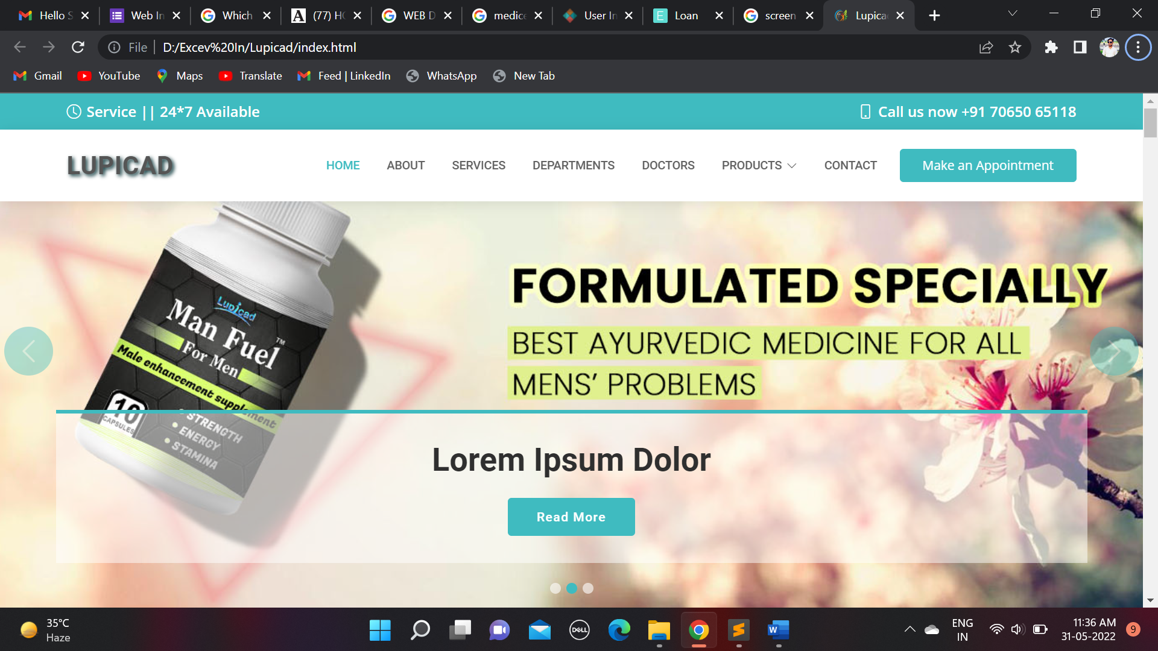

**ABOUT PAGE:**

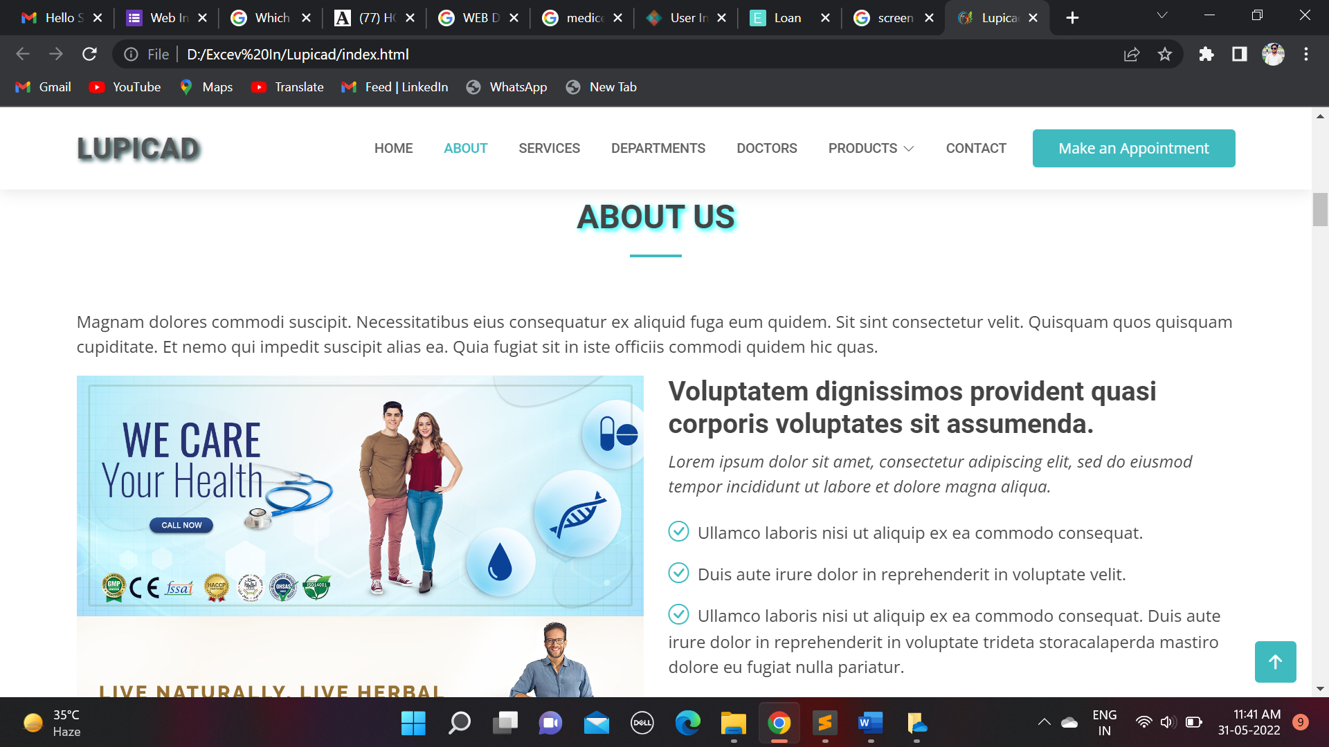

**SERVICE PAGE:**

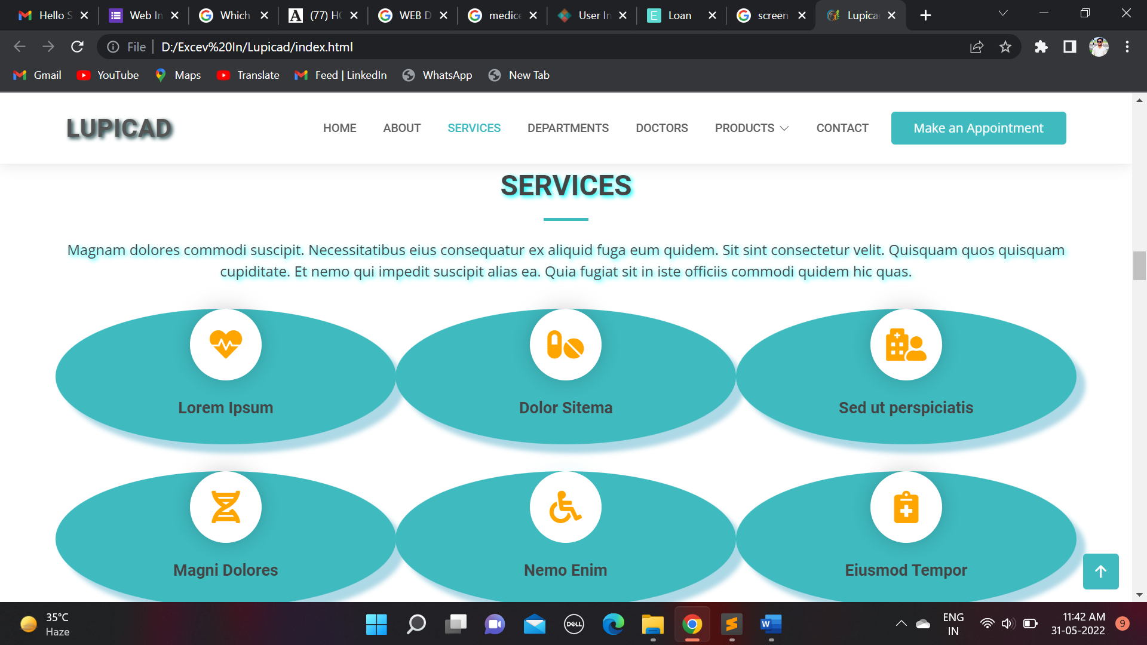

**DEPARTMENT PAGE:**

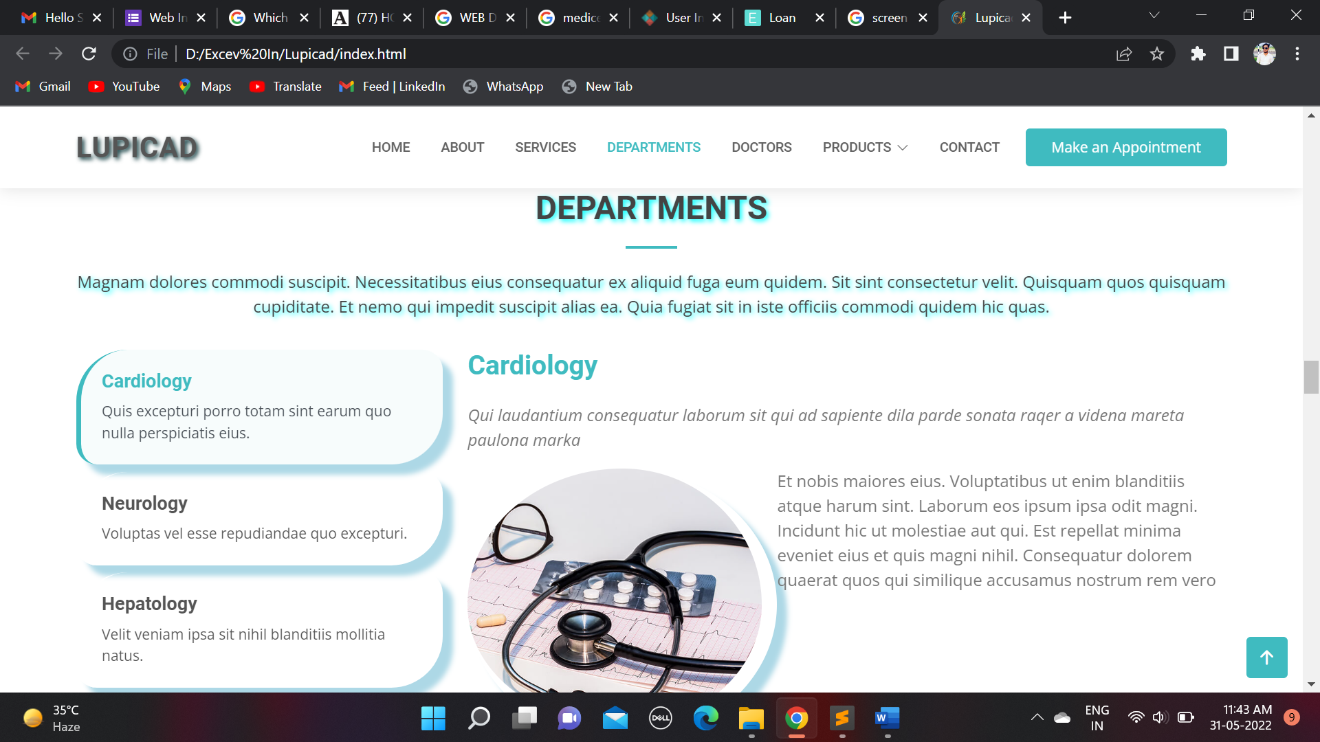

**DOCTORS PAGE:**

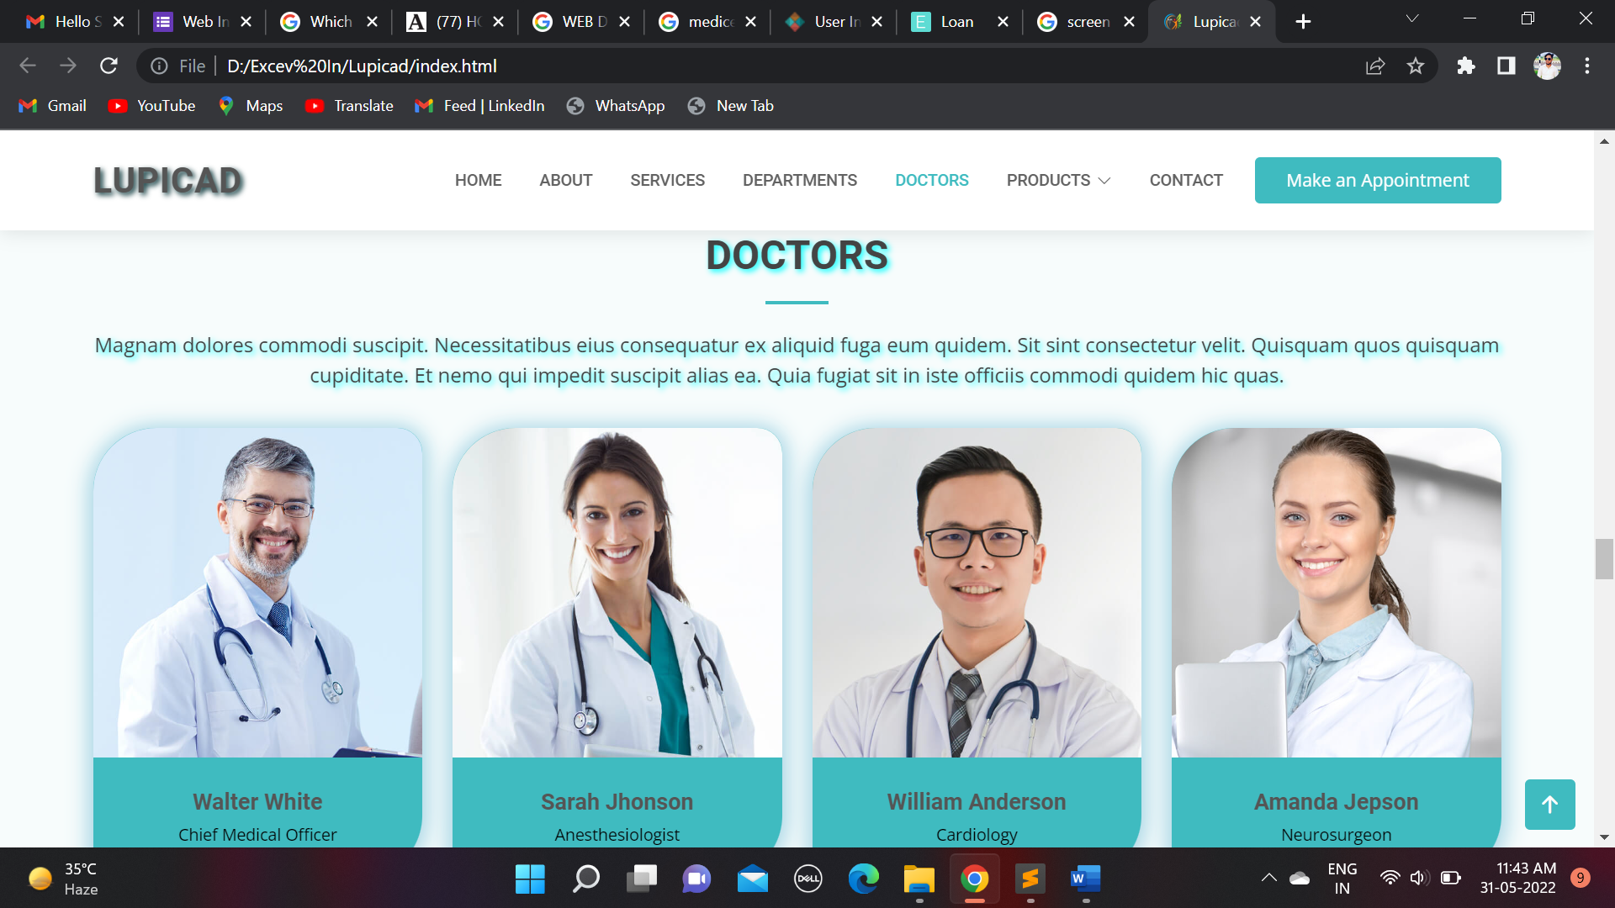

**APPOINTMENT PAGE:**

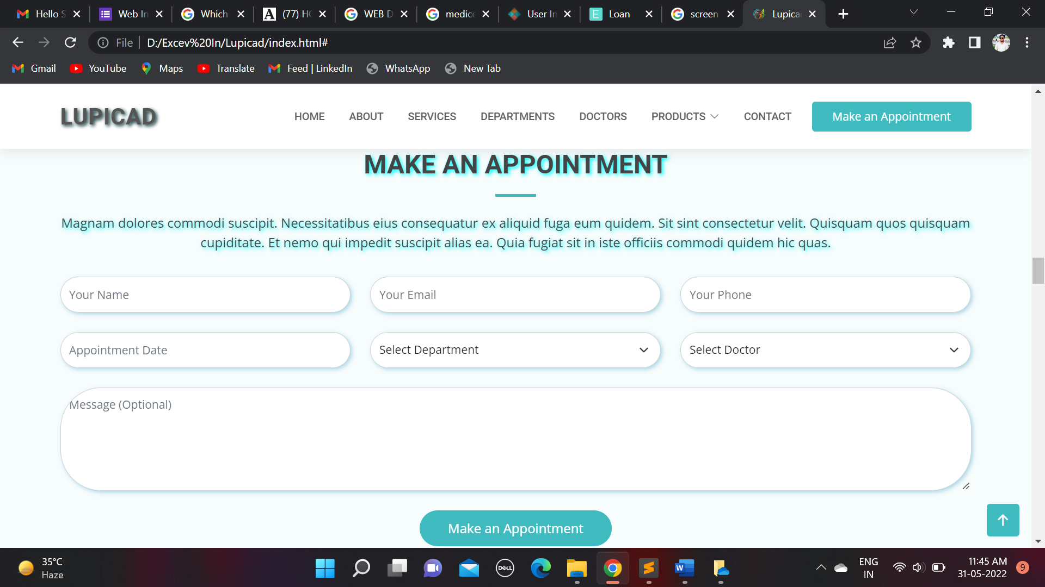

**CONTACT PAGE:**

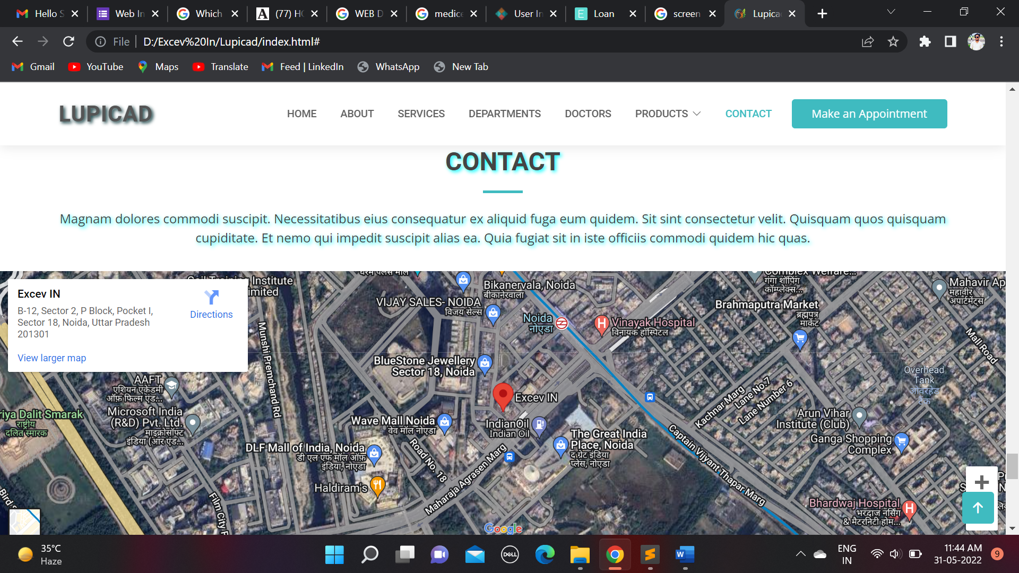

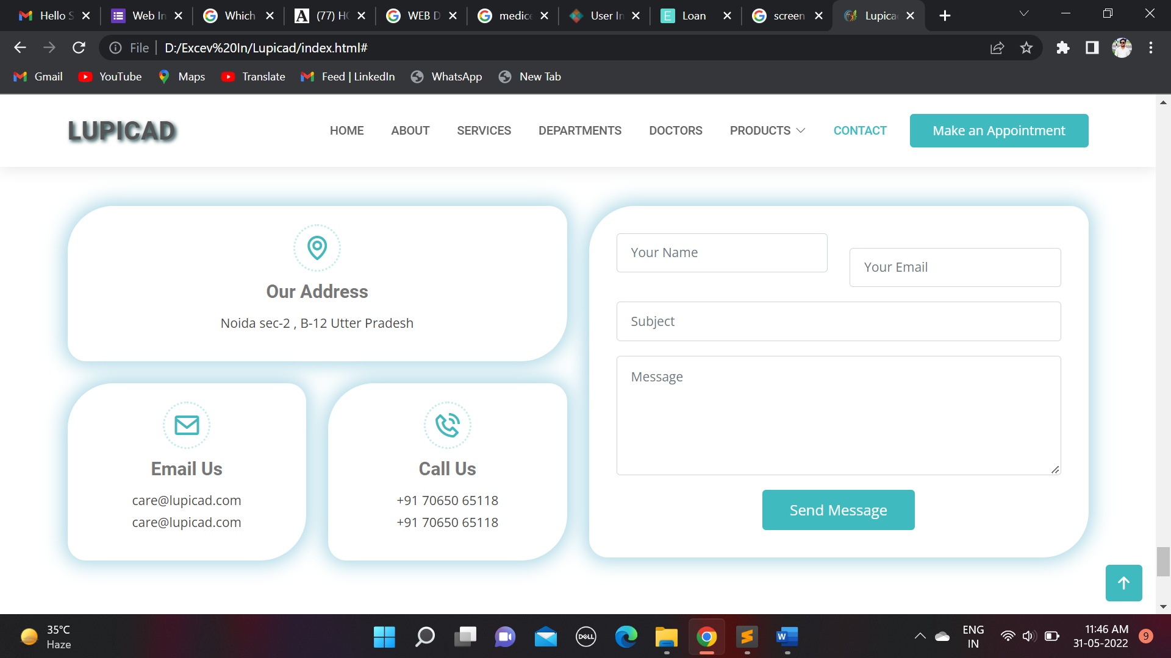

**8.CONCLUSION:**

Since we are entering details of the patients electronically in the” Hospital Management System”, data will be secured. Using this application we can retrieve patient’s history with a single click. Thus processing information will be faster. It guarantees accurate maintenance of Patient details. It easily reduces the book keeping task and thus reduces the human effort and increases accuracy speed.